2019 SERC Convention Finance Projects

Happy State Convention time SERC Executive & General Board and State Presidents! I know that you are buzzing with activities, reports, awards banquets, installations and much more, but I want to take a minute to talk about SERC and the finance projects we have planned.

With the days getting warmer, it is hard to think about Christmas, but we are bringing back an exciting finance project that could use a brief discussion at your State Convention. The “Themed Christmas Trees” are going to be auctioned off during our 2019 SERC Convention. We will provide a small- 12in or so – Christmas tree decorated in symbolic items that represent your state. We ask your state membership to bring gift cards to place on the tree and they will be auctioned off during the Convention weekend.

The timing is perfect to help you complete your Christmas shopping or an excuse to take a break from the holiday chaos with dinner, coffee or massage – using gift cards you won on your tree! Please remember that members from other states will be bidding on these trees, so try to provide gift cards that are cross geography among the southeast.

We also know that after a fun weekend at SERC full of shopping, dining and occasional adult beverages, it would be great to win some cold hard cash, to replenish your bank account for the trip back home. We will have a 50/50 raffle throughout the weekend and the winner will be drawn on Saturday. Be sure to earmark some of your mad money for those precious raffle tickets!

And lastly, SERC will host an online book party through Usborne Books & More. This company has some fantastic books and activities for any child birth and up! The party will be open for approximately a month and a half and feature an online Facebook Party as well! Our consultant will create a Facebook Party and be available to answer any questions you may have, offer suggestions for any munchkins in your life, and post videos and information about their products. I’m so excited to bring this to our region. This will be a fun way to raise money for our Ways & Means while sharing the joy of reading with our friends and family!
More details to come, so stay tuned.

Below are the projects as they were listed in the Newsletter. Please feel free to share these with your membership at your State Convention, insert in your State Newsletter, mention on you State Facebook page and any other form of communication that works for your membership. If you have any questions, please contact us at:
Tammy Gregg or Janyce Rawls
864-483-1538 318-614-4709
tammyjo21@yahoo.com. janycerawls@gmail.com

Thank you and we look forward to seeing you in Raleigh in October!
Tammy and Janyce

Our 2018-19 SERC Finance Projects

SERC will host an online book party through Usborne Books & More. This company has some fantastic books and activities for any child birth and up! The party will be open for approximately a month and a half and feature an online Facebook Party as well! Our consultant will create a Facebook Party and be available to answer any questions you may have, offer suggestions for any munchkins in your life, and post videos and information about their products. I’m so excited to bring this to our region. This will be a fun way to raise money for our Ways & Means while sharing the joy of reading with our friends and family!
Some benefits to this fundraiser:
- We can go outside of ESA members to help support our budget. You can share this party with anyone!
- Any products purchased are shipped directly to the customer. We do not have to handle any merchandise.
- You can purchase books to support a local school and count it as a Kids Cause service project!
- You can shop in your pajamas at your leisure.

Here’s the link to our online party!
https://s6416.myubam.com/1230343
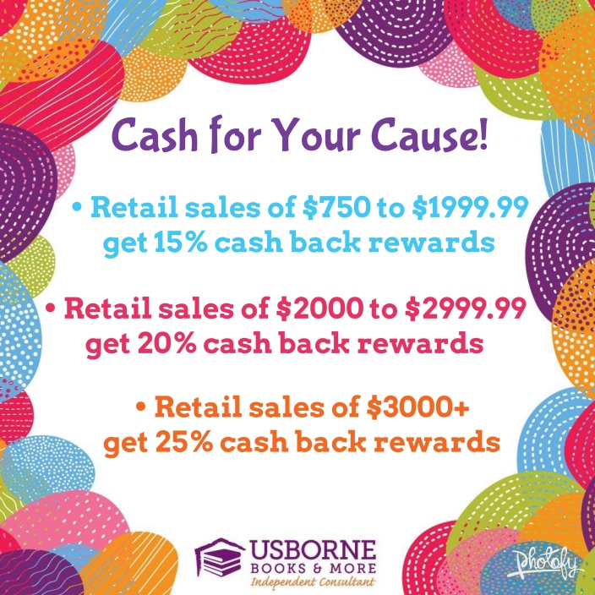

50/50 Raffle
It’s back, the ever popular 50/50 Cash Raffle. Tickets will be sold at SERC and the winner will receive half of the “pot” and the other half will go to our Finance Goal.

It’s beginning to look a lot like Christmas…

When SERC rolls around, we know the Holiday Season is just around the corner. To help us get in the spirit and raise some money, we are bringing back the popular “Themed Christmas Trees”.

Begin discussing your gift card ideas for your state tree and let’s see which state can bring the most creative and profitable tree to our weekend of fun.

Let the shopping begin!

